**Phase -5**

**Project-2**

**Report on**

**Continuous Monitoring on Docker with ELK Stack**

**-By Dr. Jyothi N.M.**

**Github Link**

<https://github.com/jyothiarunkr/Phase-5-project2-CM-on-Docker-with-ELK-Stack.git>

**Project Objective:**

Continuous Monitoring (CM) on Docker with ELK stack is the process that helps developers to monitor the application in real-time using Kibana.

**Background of the problem statement:**

XYZ Technology Solutions hired you as a DevOps Engineer. The company is undergoing an infrastructural change regarding the tools used in the organization. The company decides to implement DevOps to develop and deliver the products. Since XYZ is an agile organization, they follow Scrum methodology to develop the projects incrementally. They decide to   dockerize their applications so that they can deploy them on Kubernetes. Each application when deployed and exposed, will have a unique URL and port, using which we can access that application.

Requirement Analysis:

The application and its versions should be available on GitHub  
● Commit the code multiple times and track their versions on GitHub   
● Build the application in Docker, and host it in Docker Hub  
● Deploy ELK stack on Docker and push application logs to it  
● Automate Docker build and deployment using Jenkins pipeline code

**Tools used:**

● Docker  
● Docker Compose  
● Elasticsearch  
● Logstash   
● Kibana  
● Spring Boot application

**Complete Implementation steps along with detailed description**

**I Dcoker**

In this project, following steps are followed

1. I**nstall Docker container in windows**, to **create docker image**
2. D**eploy Docker image** (which as one simple spring boot based microservice) in developer machine.

**Docker Installation**

To install docker on Windows 10 machine, follow the bellow steps:

**Choose the appropriate Docker installer for your System**

Before starting with the installation process we need to understand the exact Docker version that is suitable for the Windows that you are using. Docker has provided two versions of Windows distribution as bellow

* For windows 10 we need to follow this link <https://docs.docker.com/docker-for-windows/>

We will follow the Docker tool box installation stepss

**Download Docker installer**

We need to first download the Docker toolbox distribution from <https://download.docker.com/win/stable/DockerToolbox.exe> and we will follow the installation steps in local Workstation.

**Enable Hardware Virtualization Technology**

In order to Docker toolbox works properly we need to make sure your Windows system supports Hardware Virtualization Technology and that virtualization is enabled. Docker has provided detailed step on this here: <https://docs.docker.com/toolbox/toolbox_install_windows/#step-1-check-your-version>.

If we don’t have this enabled then we need to go to BIOS option and enable Hardware Virtualization. The BIOS is bit different for different models of Computer, so please follow official guideline for enabling that.

**Run Docker installer**

Once we have the Installer downloaded and we have enabled the Hardware Virtualization, we can start the installer. It’s just like a simple another windows based installation process guided by a installation wizard.

**Verify your installation**

To [verify docker installation](https://docs.docker.com/toolbox/toolbox_install_windows/#step-3-verify-your-installation), open *Docker Quickstart Terminal* shortcut from either Desktop or Start menu. Verify that Docker prompt is coming and then need to test few basic commands. Docker prompt and sample docker command will look like below.

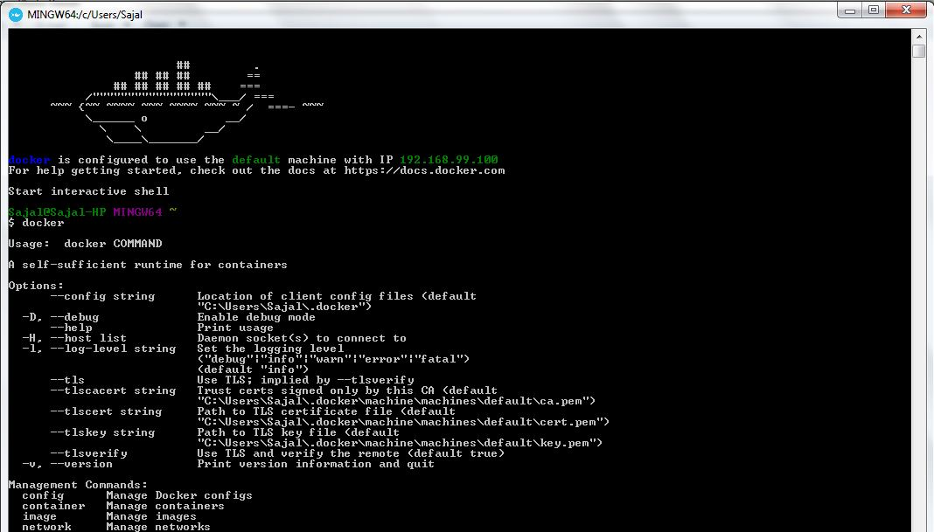

Docker installation verification

**Note Down the Docker IP**

We need to now note down the Docker IP assigned to this Container. We will access this IP to access the Applications installed inside Docker. To know the IP from the command prompt use command docker-machine ip. Here is the sample output of the command. Please note that this IP will be different for different M/Cs.

https://i2.wp.com/howtodoinjava.com/wp-content/uploads/2017/08/17-1.jpg?resize=1066%2C57docker-machine ip output

**Create docker Image**

We will first create a spring boot based REST API, add docker specific configuration and then we will create docker image.

**Create Spring REST Project**

Develop  Microservice for testing. I have used springboot and Maven and Eclipse as IDE. Add and REST  endpoints so that once this application is deployed in to Docker, we can test this by accessing the rest endpoint.

|  |
| --- |
| package com.example.howtodoinjava.hellodocker;    import java.util.Date;  import org.springframework.boot.SpringApplication;  import org.springframework.boot.autoconfigure.SpringBootApplication;  import org.springframework.web.bind.annotation.PathVariable;  import org.springframework.web.bind.annotation.RequestMapping;  import org.springframework.web.bind.annotation.RestController;    @SpringBootApplication  public class HelloDockerApplication {        public static void main(String[] args) {          SpringApplication.run(HelloDockerApplication.class, args);      }  }    @RestController  class HelloDockerRestController {      @RequestMapping("/hello/{name}")      public String helloDocker(@PathVariable(value = "name") String name) {          String response = "Hello " + name + " Response received on : " + new Date();          System.out.println(response);          return response;        }  } |

Update resources/application.properties with server port information.

|  |
| --- |
| server.port = 9080 |

Now test this microservice by running the project as spring boot application.

**Add Docker Configurations**

Now create a file named Dockerfile in the root directory and add the below lines as Docker configurations.

|  |
| --- |
| FROM openjdk:8-jdk-alpine  VOLUME /tmp  ADD target/hello-docker-0.0.1-SNAPSHOT.jar hello-docker-app.jar  ENV JAVA_OPTS=""  ENTRYPOINT [ "sh", "-c", "java $JAVA_OPTS -Djava.security.egd=file:/dev/./urandom -jar /hello-docker-app.jar" ] |

This is used by Docker while creating the image. It is basically declaring the Java runtime information and target distributions.

**Add Maven Docker Plugins**

Add two maven plugins in the pom.xml file so that we can use the Docker related maven commands while creating the instance. Those plugins are dockerfile-maven-plugin and maven-dependency-plugin.

We have used the minimal configurations required to build the project.

|  |
| --- |
| <plugin>      <groupId>com.spotify</groupId>      <artifactId>dockerfile-maven-plugin</artifactId>      <version>1.3.4</version>      <configuration>          <repository>${docker.image.prefix}/${project.artifactId}</repository>      </configuration>  </plugin>  <plugin>      <groupId>org.apache.maven.plugins</groupId>      <artifactId>maven-dependency-plugin</artifactId>      <executions>          <execution>              <id>unpack</id>              <phase>package</phase>              <goals>                  <goal>unpack</goal>              </goals>              <configuration>                  <artifactItems>                      <artifactItem>                          <groupId>${project.groupId}</groupId>                          <artifactId>${project.artifactId}</artifactId>                          <version>${project.version}</version>                      </artifactItem>                  </artifactItems>              </configuration>          </execution>      </executions>  </plugin> |

**Create Docker Image**

Now use maven command mvn clean install dockerfile:build to create docker image.

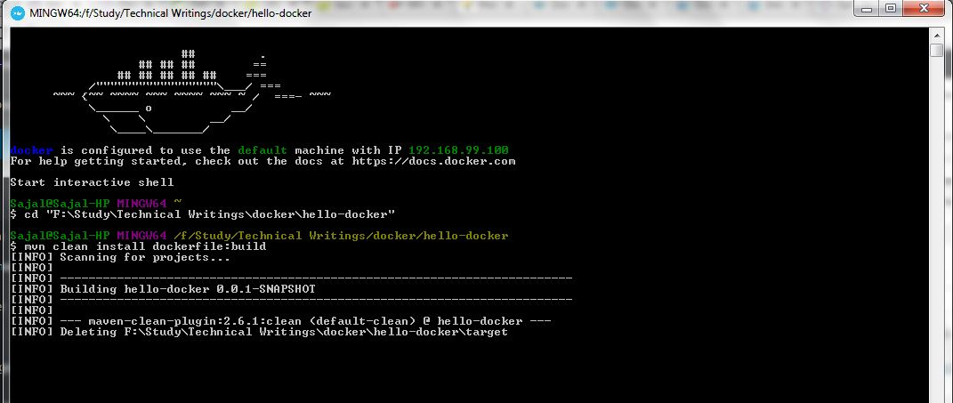Docker Image build from Docker terminal

Please make sure your local application is not running while you are building the image, in that case you might get maven build failure, as in clean step it will not be able to delete the target folder as the jar is being used by java process

Here is the last few lines of maven output log where it is building the image.

|  |
| --- |
| [INFO] Image will be built as hello-howtodoinjava/hello-docker:latest  [INFO]  [INFO] Step 1/5 : FROM openjdk:8-jdk-alpine  [INFO] Pulling from library/openjdk  [INFO] Digest: sha256:2b1f15e04904dd44a2667a07e34c628ac4b239f92f413b587538f801a0a57c88  [INFO] Status: Image is up to date for openjdk:8-jdk-alpine  [INFO]  ---> 478bf389b75b  [INFO] Step 2/5 : VOLUME /tmp  [INFO]  ---> Using cache  [INFO]  ---> f4f6473b3c25  [INFO] Step 3/5 : ADD target/hello-docker-0.0.1-SNAPSHOT.jar hello-docker-app.jar  [INFO]  ---> ce7491518508  [INFO] Removing intermediate container c74867501651  [INFO] Step 4/5 : ENV JAVA_OPTS ""  [INFO]  ---> Running in f7cd27710bf3  [INFO]  ---> 086226135205  [INFO] Removing intermediate container f7cd27710bf3  [INFO] Step 5/5 : ENTRYPOINT sh -c java $JAVA_OPTS -Djava.security.egd=file:/dev/./urandom -jar /hello-docker-app.jar  [INFO]  ---> Running in 9ef14a442715  [INFO]  ---> bf14919a32e2  [INFO] Removing intermediate container 9ef14a442715  [INFO] Successfully built bf14919a32e2  [INFO] Successfully tagged hello-howtodoinjava/hello-docker:latest  [INFO]  [INFO] Detected build of image with id bf14919a32e2  [INFO] Building jar: F:\Study\Technical Writings\docker\hello-docker\target\hello-docker-0.0.1-SNAPSHOT-docker-info.jar  [INFO] Successfully built hello-howtodoinjava/hello-docker:latest  [INFO] ------------------------------------------------------------------------  [INFO] BUILD SUCCESS  [INFO] ------------------------------------------------------------------------ |

**Deploy and Run Docker Image**

So we have created the Docker Image (i.e. hello-docker-0.0.1-SNAPSHOT-docker-info.jar). We also have a installed docker container running in our local machine.

Now, to run the docker image inside installed docker container, we will use below command.

docker run -p 8080:9080 -t hello-howtodoinjava/hello-docker --name hello-docker-image

Here the option -p 8080:9080 is important. It says that expose port 8080 for internal port 9080. Remember our application is running in port 9080 inside docker image and we will access that in port 8080 from outside Docker container.

Now access the application with URL <http://192.168.99.100:8080/hello/sajal>. Notice that the browser output is same as output of standalone REST API on localhost.

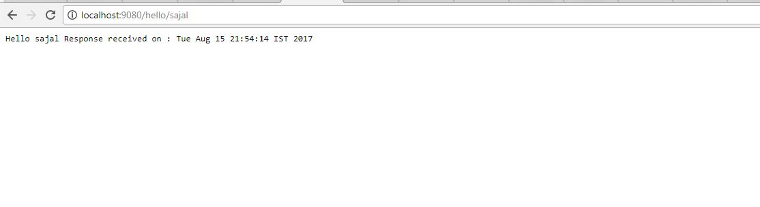

Docker Localhost Output

**Stop Docker Container**

We can list down all docker containers by command docker ps in the terminal and we can use command docker stop <name>

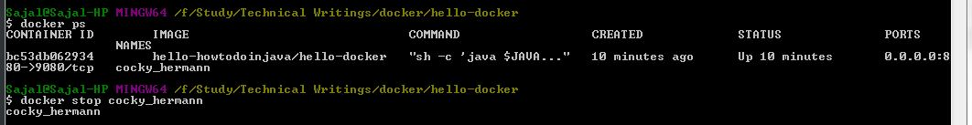Stop Docker Container

The project deployed successfully on docker

**II Integrating ELK stack to micro services ecosystem.**

 Elastic search, Logstash and Kibana– together referred as **ELK stack**. They are used for searching, analyzing, and visualizing log data in a real time.

**Steps followed**

**1. What is ELK Stack**

1. **Elasticsearch** is a distributed, JSON-based *search and analytics engine* designed for horizontal scalability, maximum reliability, and easy management.
2. **Logstash** is a dynamic *data collection pipeline* with an extensible plugin ecosystem and strong Elasticsearch synergy.
3. **Kibana** gives the *visualization* of data through a UI.

**2. ELK stack configuration**

All these three tools are based on JVM and before start installing them, please verify that JDK has been properly configured. Check that standard JDK 1.8 installation, JAVA_HOME and PATH set up is already done.

**2.1. Elasticsearch**

* Download latest version of Elasticsearch from this https://www.elastic.co/downloads/elasticsearch and unzip it any folder.
* Run bin\elasticsearch.bat from command prompt.
* By default, it would start at [http://localhost:9200](http://localhost:9200/)

**2.2. Kibana**

* Download the latest distribution from <https://www.elastic.co/downloads/kibana>  and unzip into any folder.
* Open config/kibana.yml in an editor and set elasticsearch.url to point at your Elasticsearch instance. In our case as we will use the local instance just uncomment elasticsearch.url: "http://localhost:9200"
* Run bin\kibana.bat from command prompt.
* Once started successfully, Kibana will start on default port 5601 and Kibana UI will be available at [http://localhost:5601](http://localhost:5601/)

**2.3. Logstash**

* Download the latest distribution from <https://www.elastic.co/downloads/logstash>  and unzip into any folder.
* Create one file logstash.conf as per configuration instructions. The exact configuration s shown below.

Now run bin/logstash -f logstash.conf to start logstash

ELK stack is not up and running. Now we need to create few microservices and point logstash to the API log path.

**3. ELK stack – Create Microservice**

**3.1. Create Spring Boot Project**

Crate an application using spring boot for faster development time. Follow those steps to start this service.

## 3.1. Create spring boot hello world project template

To create a template for spring boot application, use <http://start.spring.io/>. Here, you can select all dependencies which you have currently in mind, and generate the project.

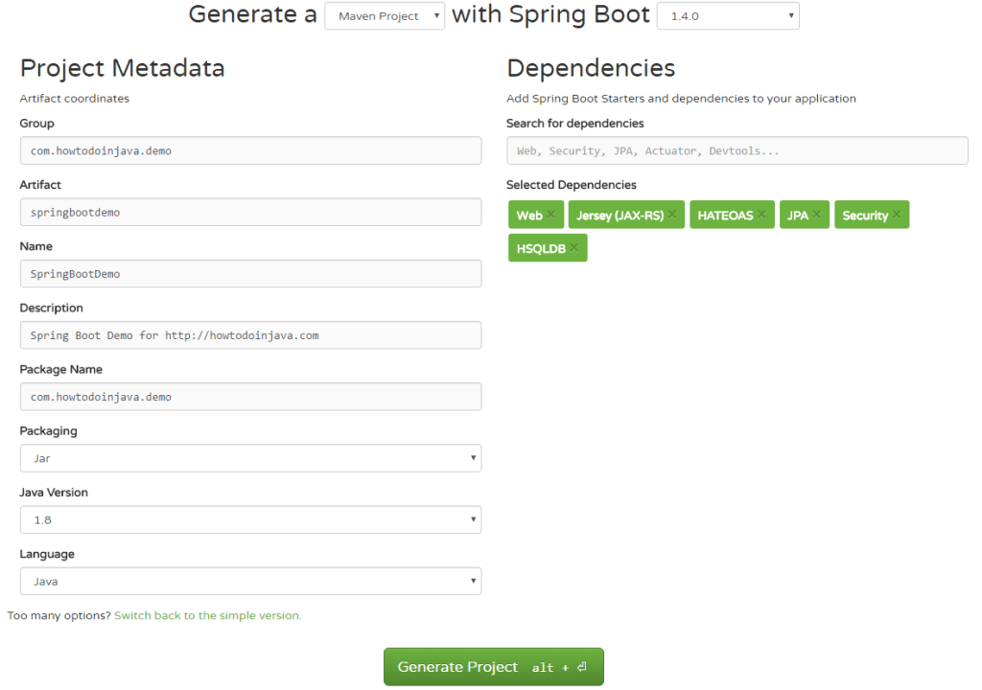Spring Boot Options

I have selected dependencies like Jersey, Spring,web , Spring HATEOAS, Spring JPA and [Spring Security](https://howtodoinjava.com/spring-security-tutorial/) etc. You can add more dependencies after you have downloaded and imported the project or in future when requirements arise.

Generate Project button will generate a .zip file. Download and extract the file into your workspace.

## 2. Import spring boot project to eclipse

Next step is to import the generated project into your IDE. I have used eclipse for this purpose.

1) Import the spring boot project as existing maven project.

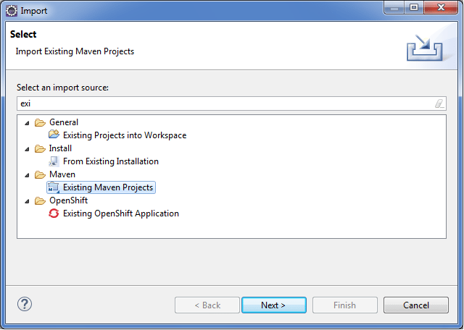Import Existing Maven Project into Eclipse

2) Select the pom.xml file to import it.

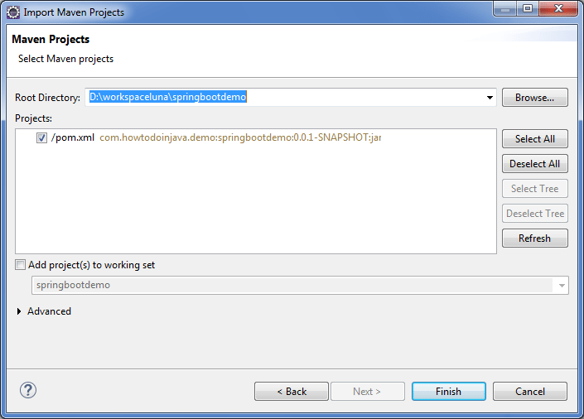Select pom.xml file to import maven project

3) Project will be imported and the dependencies you added while generating zip file, will be automatically downloaded and added into classpath.

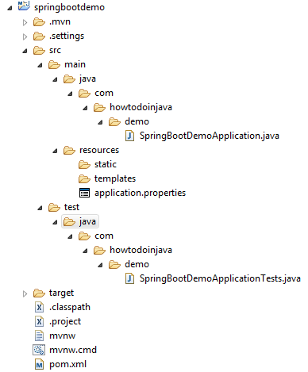

Imported Spring Boot Project Structure

I have now successfully imported spring boot application.

Look nto configuration.

## 3. Spring boot auto configuration

With spring boot, good thing is when you add a dependency (e.g. Spring security), it make fair assumptions and automatically configure some defaults for you. So you can start immediately.

Spring Boot uses convention over configuration by scanning the dependent libraries available in the class path. For each spring-boot-starter-* dependency in the POM file, Spring Boot executes a default AutoConfiguration class. AutoConfiguration classes use the *AutoConfiguration lexical pattern, where * represents the library. For example, the autoconfiguration of spring security is done through SecurityAutoConfiguration.

At the same time, if you don’t want to use auto configuration for any project, it makes it very simple. Just use exclude = SecurityAutoConfiguration.class like below.

|  |
| --- |
| @SpringBootApplication (exclude = SecurityAutoConfiguration.class)  public class SpringBootDemoApplication {     public static void main(String[] args)     {        SpringApplication.run(SpringBootDemoApplication.class, args);     }  } |

It is also possible to override default configuration values using the application.properties file in src/main/resources folder.

## 4. Spring boot annotations

Now look at @SpringBootApplication annotation what it actually does.

#### 4.1. @SpringBootApplication annotation

SpringBootApplication is defined as below:

|  |
| --- |
| @Target(ElementType.TYPE)  @Retention(RetentionPolicy.RUNTIME)  @Documented  @Inherited  @SpringBootConfiguration  @EnableAutoConfiguration  @ComponentScan(excludeFilters = @Filter(type = FilterType.CUSTOM, classes = TypeExcludeFilter.class))  public @interface SpringBootApplication  {     //more code  } |

It adds 3 important annotations for application configuration purpose.

##### @SpringBootConfiguration

|  |
| --- |
| @Configuration  public @interface SpringBootConfiguration  {     //more code  } |

1. This annotation adds @Configuration annotation to class which **mark the class a source of bean definitions for the application context.**

##### @EnableAutoConfiguration

This tells spring boot to auto configure important bean definitions based on added dependencies in pom.xml by start adding beans based on classpath settings, other beans, and various property settings.

##### @ComponentScan

This annotation tells spring boot to scan base package, find other beans/components and configure them as well.

## verify auto-configured beans by spring boot

If you ever want to know what all beans have been automatically configured into your **spring boot hello world application**, then use this code and run it.

|  |
| --- |
| SpringBootDemoApplication.java |
| import java.util.Arrays;    import org.springframework.boot.SpringApplication;  import org.springframework.boot.autoconfigure.SpringBootApplication;  import org.springframework.boot.autoconfigure.security.SecurityAutoConfiguration;  import org.springframework.context.ApplicationContext;    @SpringBootApplication (exclude = SecurityAutoConfiguration.class)  public class SpringBootDemoApplication {       public static void main(String[] args)     {        ApplicationContext ctx = SpringApplication.run(SpringBootDemoApplication.class, args);            String[] beanNames = ctx.getBeanDefinitionNames();            Arrays.sort(beanNames);            for (String beanName : beanNames)          {              System.out.println(beanName);          }     }  } |

With my pom.xml file, it generates following beans names along with plenty of other springframework.boot.autoconfigure dependencies.

|  |
| --- |
| Console |
| simpleControllerHandlerAdapter  sortResolver  spring.datasource-org.springframework.boot.autoconfigure.jdbc.DataSourceProperties  spring.hateoas-org.springframework.boot.autoconfigure.hateoas.HateoasProperties  spring.http.encoding-org.springframework.boot.autoconfigure.web.HttpEncodingProperties  spring.http.multipart-org.springframework.boot.autoconfigure.web.MultipartProperties  spring.info-org.springframework.boot.autoconfigure.info.ProjectInfoProperties  spring.jackson-org.springframework.boot.autoconfigure.jackson.JacksonProperties  spring.jpa-org.springframework.boot.autoconfigure.orm.jpa.JpaProperties  spring.jta-org.springframework.boot.autoconfigure.transaction.jta.JtaProperties  spring.mvc-org.springframework.boot.autoconfigure.web.WebMvcProperties  spring.resources-org.springframework.boot.autoconfigure.web.ResourceProperties  springBootDemoApplication  standardJacksonObjectMapperBuilderCustomizer  stringHttpMessageConverter  tomcatEmbeddedServletContainerFactory  tomcatPoolDataSourceMetadataProvider  transactionAttributeSource  transactionInterceptor  transactionManager  transactionTemplate  viewControllerHandlerMapping  viewResolver  websocketContainerCustomizer |

## 6. Using Spring boot REST API

Now it’s time to build any functionality into application. We can add functionality as per the need, I am adding a REST API.

#### 6.1. Create REST Controller

Create a package com.howtodoinjava.demo.controller and create rest controller inside it.

|  |
| --- |
| EmployeeController.java |
| import java.util.ArrayList;  import java.util.List;  import org.springframework.web.bind.annotation.RequestMapping;  import org.springframework.web.bind.annotation.RestController;  import com.howtodoinjava.demo.model.Employee;    @RestController  public class EmployeeController  {     @RequestMapping("/")      public List<Employee> getEmployees()      {        List<Employee> employeesList = new ArrayList<Employee>();        employeesList.add(new Employee(1,"lokesh","gupta","howtodoinjava@gmail.com"));        return employeesList;      }  } |

#### 6.2. Create Model

Create model class Employee.

|  |
| --- |
| Employee.java |
| public class Employee {       public Employee() {       }     public Employee(Integer id, String firstName, String lastName, String email) {        super();        this.id = id;        this.firstName = firstName;        this.lastName = lastName;        this.email = email;     }       private Integer id;     private String firstName;     private String lastName;     private String email;       //getters and setters       @Override     public String toString() {        return "Employee [id=" + id + ", firstName=" + firstName              + ", lastName=" + lastName + ", email=" + email + "]";     }  } |

## 7. Spring boot hello world example demo

Now start the application by running main() method in SpringBootDemoApplication. It will start the embedded tomcat server on port 8080.

As we have configured the demo REST API URL to root URL, you can access it on http;//localhost:8080/ itself.

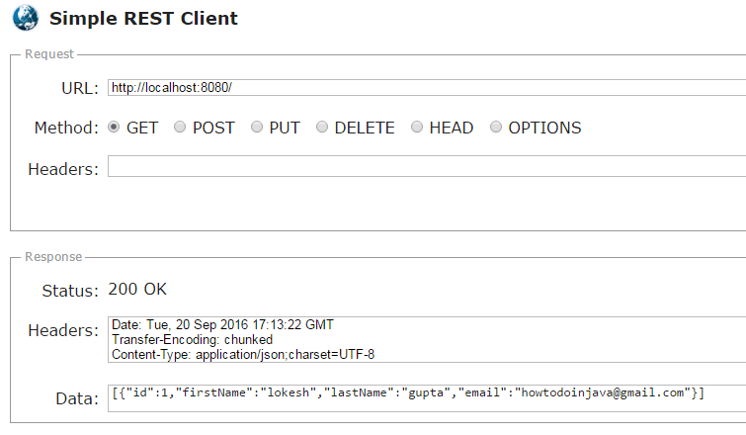Verify Spring Boot REST API

You will get the below response in testing tool or browser.

[{"id":1,"firstName":"lokesh","lastName":"gupta","email":"howtodoinjava@gmail.com"}]

That’s all for this **spring boot rest hello world example** with simple **rest api** example.

**3.2. Add REST Endpoints**

Add one RestController class which will expose few endpoints like /elk, /elkdemo, /exception. Actually we are going to test few log statements only, so feel free to add/modify logs as per your choice.

|  |
| --- |
| package com.example.howtodoinjava.elkexamplespringboot;    import java.io.PrintWriter;  import java.io.StringWriter;  import java.util.Date;    import org.apache.log4j.Level;  import org.apache.log4j.Logger;  import org.springframework.beans.factory.annotation.Autowired;  import org.springframework.boot.SpringApplication;  import org.springframework.boot.autoconfigure.SpringBootApplication;  import org.springframework.context.annotation.Bean;  import org.springframework.core.ParameterizedTypeReference;  import org.springframework.http.HttpMethod;  import org.springframework.web.bind.annotation.RequestMapping;  import org.springframework.web.bind.annotation.RestController;  import org.springframework.web.client.RestTemplate;    @SpringBootApplication  public class ElkExampleSpringBootApplication {        public static void main(String[] args) {          SpringApplication.run(ElkExampleSpringBootApplication.class, args);      }  }    @RestController  class ELKController {      private static final Logger LOG = Logger.getLogger(ELKController.class.getName());        @Autowired      RestTemplate restTemplete;        @Bean      RestTemplate restTemplate() {          return new RestTemplate();      }        @RequestMapping(value = "/elkdemo")      public String helloWorld() {          String response = "Hello user ! " + new Date();          LOG.log(Level.INFO, "/elkdemo - &gt; " + response);            return response;      }        @RequestMapping(value = "/elk")      public String helloWorld1() {            String response = restTemplete.exchange("<http://localhost:8080/elkdemo>", HttpMethod.GET, null, new ParameterizedTypeReference() {          }).getBody();          LOG.log(Level.INFO, "/elk - &gt; " + response);            try {              String exceptionrsp = restTemplete.exchange("<http://localhost:8080/exception>", HttpMethod.GET, null, new ParameterizedTypeReference() {              }).getBody();              LOG.log(Level.INFO, "/elk trying to print exception - &gt; " + exceptionrsp);              response = response + " === " + exceptionrsp;          } catch (Exception e) {              // exception should not reach here. Really bad practice :)          }            return response;      }        @RequestMapping(value = "/exception")      public String exception() {          String rsp = "";          try {              int i = 1 / 0;              // should get exception          } catch (Exception e) {              e.printStackTrace();              LOG.error(e);                StringWriter sw = new StringWriter();              PrintWriter pw = new PrintWriter(sw);              e.printStackTrace(pw);              String sStackTrace = sw.toString(); // stack trace as a string              LOG.error("Exception As String :: - &gt; "+sStackTrace);                rsp = sStackTrace;          }            return rsp;      }  } |

**3.3. Configure Spring boot Logging**

Open application.properties under resources folder and add below configuration entries.

|  |
| --- |
| logging.file=elk-example.log  spring.application.name = elk-example |

**3.4. Verify Microservice Generated Logs**

Do a final maven build using mvn clean install and start the application using command java -jar target\elk-example-spring-boot-0.0.1-SNAPSHOT.jar and test by browsing <http://localhost:8080/elk>.

Don’t be afraid by seeing the big stack trace in the screen as it has been done intentionally to see how ELK handles exception message.

Go to the application root directory and verify that the log file i.e. elk-example.log has been created and do a couple of visits to the endpoints and verify that logs are getting added in the log file.

**4. Logstash Configuration**

We need to create a logstash configuration file so that it listen to the log file and push log messages to elastic search. Here is the logstash configuration used in this project please change the log path as per your setup.

|  |
| --- |
| input {    file {      type => "java"      path => "F:/Study/eclipse_workspace_mars/elk-example-spring-boot/elk-example.log"      codec => multiline {        pattern => "^%{YEAR}-%{MONTHNUM}-%{MONTHDAY} %{TIME}.*"        negate => "true"        what => "previous"      }    }  }    filter {    #If log line contains tab character followed by 'at' then we will tag that entry as stacktrace    if [message] =~ "\tat" {      grok {        match => ["message", "^(\tat)"]        add_tag => ["stacktrace"]      }    }     grok {      match => [ "message",                 "(?<timestamp>%{YEAR}-%{MONTHNUM}-%{MONTHDAY} %{TIME})  %{LOGLEVEL:level} %{NUMBER:pid} --- \[(?<thread>[A-Za-z0-9-]+)\] [A-Za-z0-9.]*\.(?<class>[A-Za-z0-9#_]+)\s*:\s+(?<logmessage>.*)",                 "message",                 "(?<timestamp>%{YEAR}-%{MONTHNUM}-%{MONTHDAY} %{TIME})  %{LOGLEVEL:level} %{NUMBER:pid} --- .+? :\s+(?<logmessage>.*)"               ]    }        date {      match => [ "timestamp" , "yyyy-MM-dd HH:mm:ss.SSS" ]    }  }    output {      stdout {      codec => rubydebug    }      # Sending properly parsed log events to elasticsearch    elasticsearch {      hosts => ["localhost:9200"]    }  } |

**5. Kibana Configuration**

Before viewing the logs in Kibana, we need to configure the Index Patterns. We can configure logstash-* as default configuration. We can always change this index pattern in logstash side and configure in Kibana. For simplicity, we will work with default configuration.

The index pattern management page will look like below. With this configuration we are pointing Kibana to Elasticsearch index(s) of your choice. Logstash creates indices with the name pattern of logstash-YYYY.MM.DD We can do all those configuration in Kibana console <http://localhost:5601/app/kibana> and going to Management link in left panel.

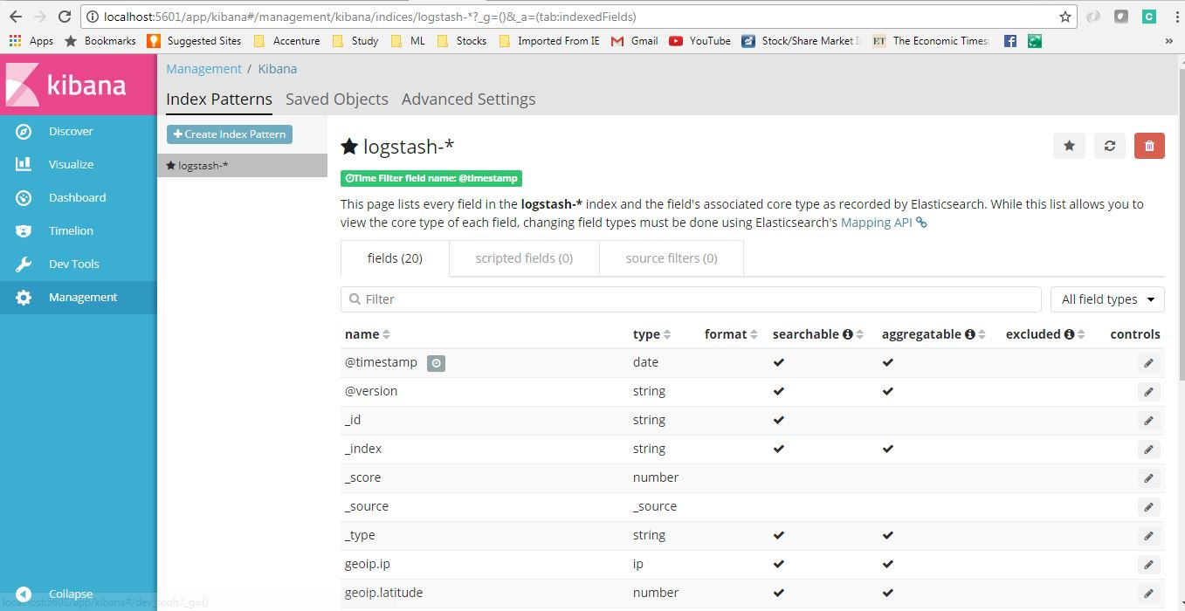Logstash configuration in Kibana

**6. Verify ELK Stack**

Now when all components are up and running, let’s verify the whole ecosystem.

Go to application and test the end points couple of times so that logs got generated and then go to Kibana console and see that logs are properly stacked in the Kibana with lots of extra feature like we can filter, see different graphs etc in built.

Here is the view of generated logs in Kibana.

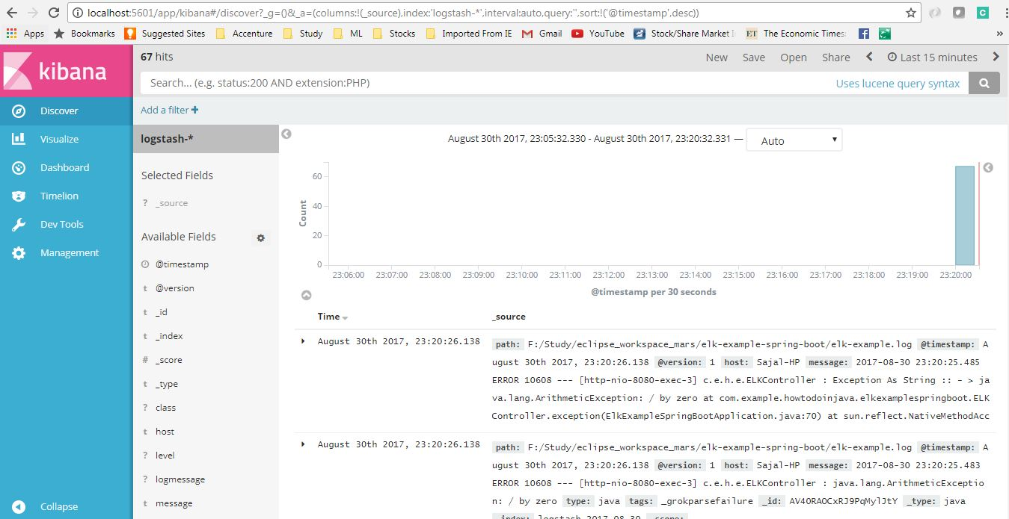Kibana Logs Overview

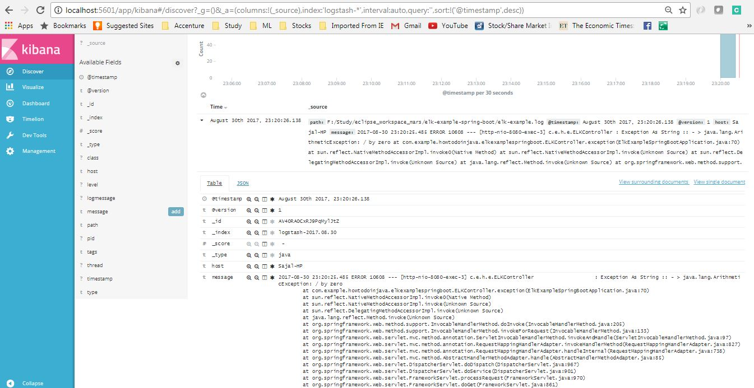Kibana Logs details screen

**IV Automate Docker build and deployment using Jenkins pipeline code**

#### On Windows

The Jenkins project provides a Linux container image, not a Windows container image. Be sure that your Docker for Windows installation is configured to run Linux Containers rather than Windows Containers.. Once configured to run Linux Containers, the steps are:

1. Open up a command prompt window do the following:
2. Create a bridge network in Docker

docker network create jenkins

1. Run a docker:dind Docker image
2. docker run --name jenkins-docker --rm --detach ^
3. --privileged --network jenkins --network-alias docker ^
4. --env DOCKER_TLS_CERTDIR=/certs ^
5. --volume jenkins-docker-certs:/certs/client ^
6. --volume jenkins-data:/var/jenkins_home ^

docker:dind

1. Build a customised official Jenkins Docker image using above Dockerfile and docker build command.
2. Run your own myjenkins-blueocean:1.1 image as a container in Docker using the following [docker run](https://docs.docker.com/engine/reference/run/) command:
3. docker run --name jenkins-blueocean --rm --detach ^
4. --network jenkins --env DOCKER_HOST=tcp://docker:2376 ^
5. --env DOCKER_CERT_PATH=/certs/client --env DOCKER_TLS_VERIFY=1 ^
6. --volume jenkins-data:/var/jenkins_home ^
7. --volume jenkins-docker-certs:/certs/client:ro ^
8. --volume "%HOMEDRIVE%%HOMEPATH%":/home ^

--publish 8080:8080 --publish 50000:50000 myjenkins-blueocean:1.1

1. Proceed to the [Setup wizard](https://www.jenkins.io/doc/tutorials/build-a-java-app-with-maven/#setup-wizard).

#### Accessing the Docker container

To access Docker container through a terminal/command prompt using the [docker exec](https://docs.docker.com/engine/reference/commandline/exec/) command, you can add an option like --name jenkins-tutorial to the docker exec command. That will access the Jenkins Docker container named "jenkins-tutorial".

This means you could access your docker container (through a separate terminal/command prompt window) with a docker exec command like:

docker exec -it jenkins-blueocean bash

#### Accessing the Docker logs

There is a possibility you may need to access the Jenkins console log, for instance, when [Unlocking Jenkins](https://www.jenkins.io/doc/tutorials/build-a-java-app-with-maven/#unlocking-jenkins) as part of the [Post-installation setup wizard](https://www.jenkins.io/doc/tutorials/build-a-java-app-with-maven/#setup-wizard).

The Jenkins console log is easily accessible through the terminal/command prompt window from which you executed the docker run …​ command. In case if needed you can also access the Jenkins console log through the [Docker logs](https://docs.docker.com/engine/reference/commandline/logs/) of your container using the following command:

docker logs <docker-container-name>

Your <docker-container-name> can be obtained using the docker ps command.

#### Accessing the Jenkins home directory

There is a possibility you may need to access the Jenkins home directory, for instance, to check the details of a Jenkins build in the workspace subdirectory.

If you mapped the Jenkins home directory (/var/jenkins_home) to one on your machine’s local file system (i.e. in the docker run …​ command [above](https://www.jenkins.io/doc/tutorials/build-a-java-app-with-maven/#downloading-and-running-jenkins-in-docker)), then you can access the contents of this directory through your machine’s usual terminal/command prompt.

Otherwise, if you specified the --volume jenkins-data:/var/jenkins_home option in the docker run …​ command, you can access the contents of the Jenkins home directory through your container’s terminal/command prompt using the [docker container exec](https://docs.docker.com/engine/reference/commandline/container_exec/) command:

docker container exec -it <docker-container-name> bash

As mentioned [above](https://www.jenkins.io/doc/tutorials/build-a-java-app-with-maven/#accessing-the-jenkins-console-log-through-docker-logs), your <docker-container-name> can be obtained using the [docker container ls](https://docs.docker.com/engine/reference/commandline/container_ls/) command. If you specified the  
--name jenkins-blueocean option in the docker container run …​command above (see also [Accessing the Jenkins/Blue Ocean Docker container](https://www.jenkins.io/doc/tutorials/build-a-java-app-with-maven/#accessing-the-jenkins-blue-ocean-docker-container)), you can simply use the docker container exec command:

docker container exec -it jenkins-blueocean bash

#### Setup wizard

Before you can access Jenkins, there are a few quick "one-off" steps you’ll need to perform.

##### **Unlocking Jenkins**

When you first access a new Jenkins instance, you are asked to unlock it using an automatically-generated password.

1. After the 2 sets of asterisks appear in the terminal/command prompt window, browse to http://localhost:8080 and wait until the **Unlock Jenkins** page appears.

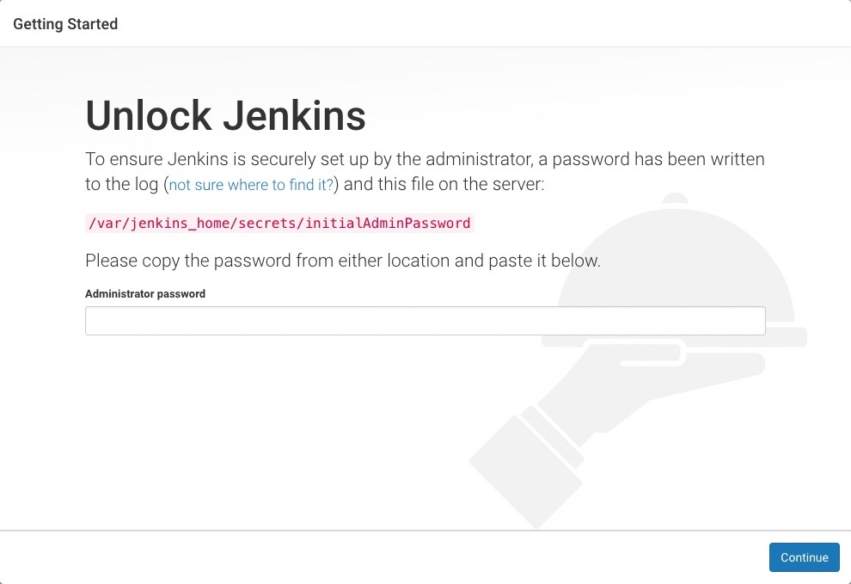

1. Display the Jenkins console log with the command:

docker logs jenkins-blueocean

1. From your terminal/command prompt window again, copy the automatically-generated alphanumeric password (between the 2 sets of asterisks).

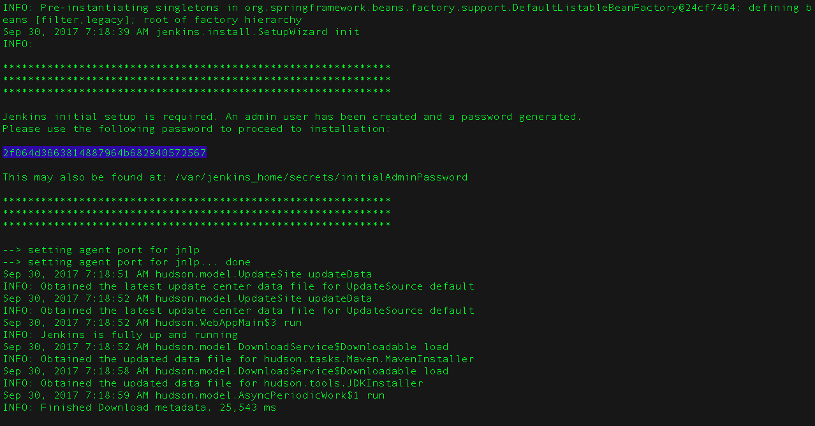

1. On the **Unlock Jenkins** page, paste this password into the **Administrator password** field and click **Continue**.

##### **Customizing Jenkins with plugins**

After [unlocking Jenkins](https://www.jenkins.io/doc/tutorials/build-a-java-app-with-maven/#unlocking-jenkins), the **Customize Jenkins** page appears.

On this page, click **Install suggested plugins**.

The setup wizard shows the progression of Jenkins being configured and the suggested plugins being installed. This process may take a few minutes.

##### **Creating the first administrator user**

Finally, Jenkins asks you to create your first administrator user.

1. When the **Create First Admin User** page appears, specify your details in the respective fields and click **Save and Finish**.
2. When the **Jenkins is ready** page appears, click **Start using Jenkins**.  
   **Notes:**
   * This page may indicate **Jenkins is almost ready!** instead and if so, click **Restart**.
   * If the page doesn’t automatically refresh after a minute, use your web browser to refresh the page manually.
3. If required, log in to Jenkins with the credentials of the user you just created and you’re ready to start using Jenkins!

#### Stopping and restarting Jenkins

Throughout the remainder of this tutorial, you can stop your Docker container by running:

docker stop jenkins-blueocean jenkins-docker

To restart your Docker container:

1. Run the same docker run …​ commands you ran for [macOS, Linux](https://www.jenkins.io/doc/tutorials/build-a-java-app-with-maven/" \l "on-macos-and-linux) or [Windows](https://www.jenkins.io/doc/tutorials/build-a-java-app-with-maven/#on-windows) above.
2. Browse to http://localhost:8080.
3. Wait until the log in page appears and log in.

### Fork and clone the sample repository

Obtain the Java application from GitHub, by forking the sample repository of the application’s source code into your own GitHub account and then cloning this fork locally.

1. Ensure you are signed in to your GitHub account. If you don’t yet have a GitHub account, sign up for a free one on the [GitHub website](https://github.com/).
2. Fork the [simple-java-maven-app](https://github.com/jenkins-docs/simple-java-maven-app) on GitHub into your local GitHub account. If you need help with this process, refer to the [Fork A Repo](https://help.github.com/articles/fork-a-repo/) documentation on the GitHub website for more information.
3. Clone your forked simple-java-maven-app repository (on GitHub) locally to your machine. To begin this process, do either of the following (where <your-username> is the name of your user account on your operating system):
   * If you have the GitHub Desktop app installed on your machine:
     1. In GitHub, click the green **Clone or download** button on your forked repository, then **Open in Desktop**.
     2. In GitHub Desktop, before clicking **Clone** on the **Clone a Repository** dialog box, ensure **Local Path** for:
        + macOS is /Users/<your-username>/Documents/GitHub/simple-java-maven-app
        + Linux is /home/<your-username>/GitHub/simple-java-maven-app
        + Windows is C:\Users\<your-username>\Documents\GitHub\simple-java-maven-app
   * Otherwise:
     1. Open up a terminal/command line prompt and cd to the appropriate directory on:
        + macOS - /Users/<your-username>/Documents/GitHub/
        + Linux - /home/<your-username>/GitHub/
        + Windows - C:\Users\<your-username>\Documents\GitHub\ (although use a Git bash command line window as opposed to the usual Microsoft command prompt)
     2. Run the following command to continue/complete cloning your forked repo:  
        git clone https://github.com/YOUR-GITHUB-ACCOUNT-NAME/simple-java-maven-app  
        where YOUR-GITHUB-ACCOUNT-NAME is the name of your GitHub account.

### Create your Pipeline project in Jenkins

1. Go back to Jenkins, log in again if necessary and click **create new jobs** under **Welcome to Jenkins!**  
   **Note:** If you don’t see this, click **New Item** at the top left.
2. In the **Enter an item name** field, specify the name for your new Pipeline project (e.g. simple-java-maven-app).
3. Scroll down and click **Pipeline**, then click **OK** at the end of the page.
4. ( Optional ) On the next page, specify a brief description for your Pipeline in the **Description** field (e.g. An entry-level Pipeline demonstrating how to use Jenkins to build a simple Java application with Maven.)
5. Click the **Pipeline** tab at the top of the page to scroll down to the **Pipeline** section.
6. From the **Definition** field, choose the **Pipeline script from SCM** option. This option instructs Jenkins to obtain your Pipeline from Source Control Management (SCM), which will be your locally cloned Git repository.
7. From the **SCM** field, choose **Git**.
8. In the **Repository URL** field, specify the directory path of your locally cloned repository [above](https://www.jenkins.io/doc/tutorials/build-a-java-app-with-maven/#fork-sample-repository), which is from your user account/home directory on your host machine, mapped to the /home directory of the Jenkins container - i.e.
   * For Windows - /home/Documents/GitHub/simple-java-maven-app
9. Click **Save** to save your new Pipeline project. You’re now ready to begin creating your Jenkinsfile, which you’ll be checking into your locally cloned Git repository.

### Create your initial Pipeline as a Jenkinsfile

You’re now ready to create your Pipeline that will automate building your Java application with Maven in Jenkins. Your Pipeline will be created as a Jenkinsfile, which will be committed to your locally cloned Git repository (simple-java-maven-app).

This is the foundation of "Pipeline-as-Code", which treats the continuous delivery pipeline as a part of the application to be versioned and reviewed like any other code. Read more about Pipeline and what a Jenkinsfile is in the [Pipeline](https://www.jenkins.io/doc/book/pipeline) and [Using a Jenkinsfile](https://www.jenkins.io/doc/book/pipeline/jenkinsfile) sections of the User Handbook.

First, create an initial Pipeline to download a Maven Docker image and run it as a Docker container (which will build your simple Java application). Also add a "Build" stage to the Pipeline that begins orchestrating this whole process.

1. Using your favorite text editor or IDE, create and save new text file with the name Jenkinsfile at the root of your local simple-java-maven-app Git repository.
2. Copy the following Declarative Pipeline code and paste it into your empty Jenkinsfile:
3. pipeline {
4. agent {
5. docker {
6. image 'maven:3-alpine'
7. args '-v /root/.m2:/root/.m2'
8. }
9. }
10. stages {
11. stage('Build') {
12. steps {
13. sh 'mvn -B -DskipTests clean package'
14. }
15. }
16. }

}

|  |  |
| --- | --- |
|  | This image parameter (of the [agent](https://www.jenkins.io/doc/book/pipeline/syntax#agent) section’s docker parameter) downloads the [maven:3-alpine Docker image](https://hub.docker.com/_/maven/) (if it’s not already available on your machine) and runs this image as a separate container. This means that:   * + You’ll have separate Jenkins and Maven containers running locally in Docker.   + The Maven container becomes the [agent](https://www.jenkins.io/doc/book/glossary/#agent) that Jenkins uses to run your Pipeline project. However, this container is short-lived - its lifespan is only that of the duration of your Pipeline’s execution. |
|  | This args parameter creates a reciprocal mapping between the /root/.m2 (i.e. Maven repository) directories in the short-lived Maven Docker container and that of your Docker host’s filesystem. Explaining the details behind this is beyond the scope of this tutorial. However, the main reason for doing this is to ensure that the artifacts necessary to build your Java application (which Maven downloads while your Pipeline is being executed) are retained in the Maven repository beyond the lifespan of the Maven container. This prevents Maven from having to download the same artifacts during successive runs of your Jenkins Pipeline, which you’ll be conducting later on. Be aware that unlike the Docker data volume you created for jenkins-data [above](https://www.jenkins.io/doc/tutorials/build-a-java-app-with-maven/#download-and-run-jenkins-in-docker), the Docker host’s filesystem is effectively cleared out each time Docker is restarted. This means you’ll lose the downloaded Maven repository artifacts each time Docker restarts. |
|  | Defines a [stage](https://www.jenkins.io/doc/book/pipeline/syntax/#stage) (directive) called Build that appears on the Jenkins UI. |
|  | This [sh](https://www.jenkins.io/doc/pipeline/steps/workflow-durable-task-step/" \l "code-sh-code-shell-script) step (of the [steps](https://www.jenkins.io/doc/book/pipeline/syntax/#steps) section) runs the Maven command to cleanly build your Java application (without running any tests). |

1. Save your edited Jenkinsfile and commit it to your local simple-java-maven-app Git repository. E.g. Within the simple-java-maven-app directory, run the commands:  
   git add .  
   then  
   git commit -m "Add initial Jenkinsfile"
2. Go back to Jenkins again, log in again if necessary and click **Open Blue Ocean** on the left to access Jenkins’s Blue Ocean interface.
3. In the **This job has not been run** message box, click **Run**, then quickly click the **OPEN** link which appears briefly at the lower-right to see Jenkins running your Pipeline project. If you weren’t able to click the **OPEN** link, click the row on the main Blue Ocean interface to access this feature.  
   **Note:** You may need to wait several minutes for this first run to complete. After making a clone of your local simple-java-maven-app Git repository itself, Jenkins:
   * Initially queues the project to be run on the agent.
   * Downloads the Maven Docker image and runs it in a container on Docker.

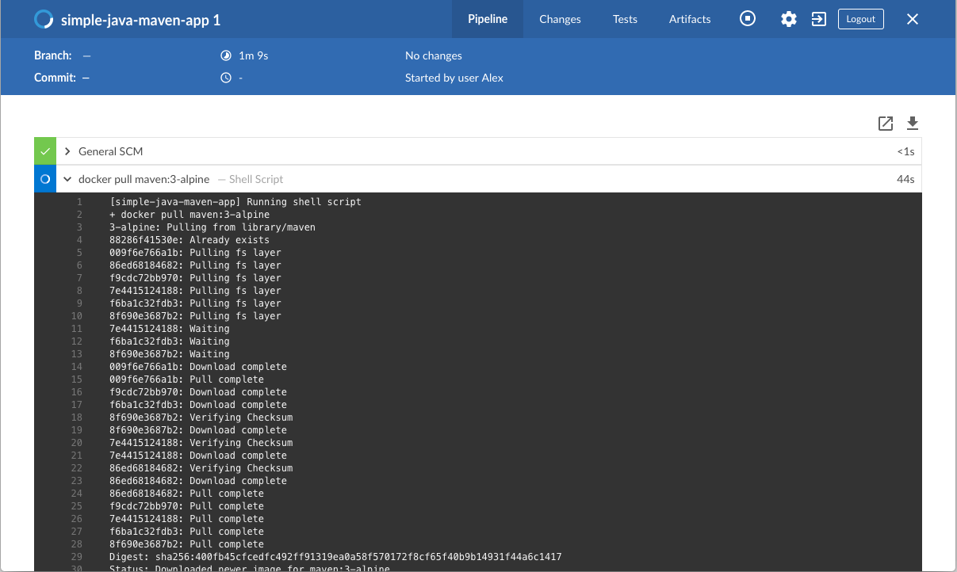

* + Runs the Build stage (defined in the Jenkinsfile) on the Maven container. During this time, Maven downloads many artifacts necessary to build your Java application, which will ultimately be stored in Jenkins’s local Maven repository (in the Docker host’s filesystem).

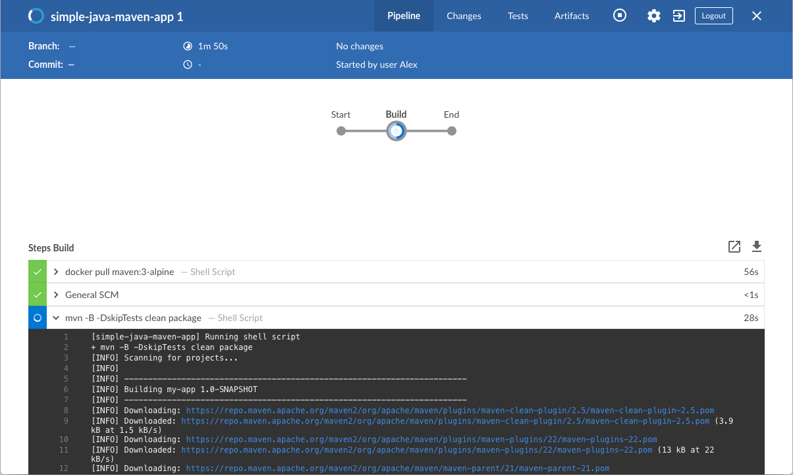

1. The Blue Ocean interface turns green if Jenkins built your Java application successfully.
2. Click the **X** at the top-right to return to the main Blue Ocean interface.

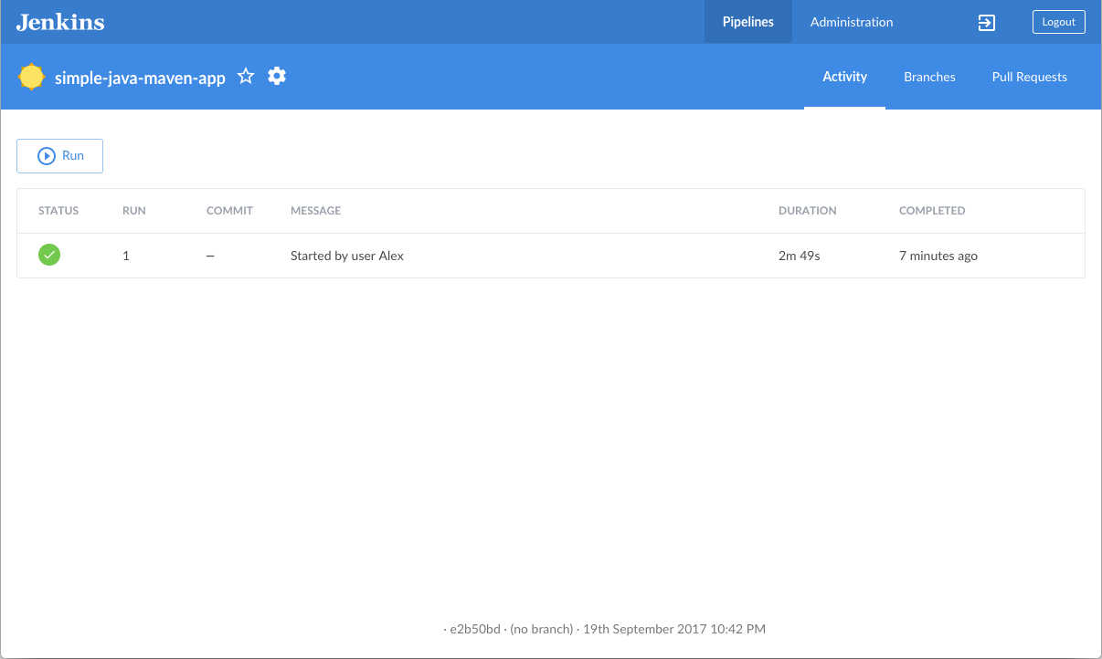

### Add a test stage to your Pipeline

1. Go back to your text editor/IDE and ensure your Jenkinsfile is open.
2. Copy and paste the following Declarative Pipeline syntax immediately under the Build stage of your Jenkinsfile:
3. stage('Test') {
4. steps {
5. sh 'mvn test'
6. }
7. post {
8. always {
9. junit 'target/surefire-reports/*.xml'
10. }
11. }

}

so that you end up with:

pipeline {

agent {

docker {

image 'maven:3-alpine'

args '-v /root/.m2:/root/.m2'

}

}

stages {

stage('Build') {

steps {

sh 'mvn -B -DskipTests clean package'

}

}

stage('Test') {

steps {

sh 'mvn test'

}

post {

always {

junit 'target/surefire-reports/*.xml'

}

}

}

}

}

|  |  |
| --- | --- |
|  | Defines a [stage](https://www.jenkins.io/doc/book/pipeline/syntax/#stage) (directive) called Test that appears on the Jenkins UI. |
|  | This [sh](https://www.jenkins.io/doc/pipeline/steps/workflow-durable-task-step/" \l "code-sh-code-shell-script) step (of the [steps](https://www.jenkins.io/doc/book/pipeline/syntax/#steps) section) executes the Maven command to run the unit test on your simple Java application. This command also generates a JUnit XML report, which is saved to the target/surefire-reports directory (within the /var/jenkins_home/workspace/simple-java-maven-app directory in the Jenkins container). |
|  | This [junit](https://www.jenkins.io/doc/pipeline/steps/junit/" \l "code-junit-code-archive-junit-formatted-test-results) step (provided by the [JUnit Plugin](https://www.jenkins.io/doc/pipeline/steps/junit)) archives the JUnit XML report (generated by the mvn test command above) and exposes the results through the Jenkins interface. In Blue Ocean, the results are accessible through the **Tests** page of a Pipeline run. The [post](https://www.jenkins.io/doc/book/pipeline/syntax/#post) section’s always condition that contains this junit step ensures that the step is always executed at the completion of the Test stage, regardless of the stage’s outcome. |

1. Save your edited Jenkinsfile and commit it to your local simple-java-maven-app Git repository. E.g. Within the simple-java-maven-app directory, run the commands:  
   git stage .  
   then  
   git commit -m "Add 'Test' stage"
2. Go back to Jenkins again, log in again if necessary and ensure you’ve accessed Jenkins’s Blue Ocean interface.
3. Click **Run** at the top left, then quickly click the **OPEN** link which appears briefly at the lower-right to see Jenkins running your amended Pipeline project. If you weren’t able to click the **OPEN** link, click the top row on the Blue Ocean interface to access this feature.  
   **Note:** You’ll notice from this run that Jenkins no longer needs to download the Maven Docker image. Instead, Jenkins only needs to run a new container from the Maven image downloaded previously. Also, if Docker had not restarted since you last ran the Pipeline [above](https://www.jenkins.io/doc/tutorials/build-a-java-app-with-maven/#create-your-initial-pipeline-as-a-jenkinsfile), then no Maven artifacts need to be downloaded during the "Build" stage. Therefore, running your Pipeline this subsequent time should be much faster.  
   If your amended Pipeline ran successfully, here’s what the Blue Ocean interface should look like. Notice the additional "Test" stage. You can click on the previous "Build" stage circle to access the output from that stage.

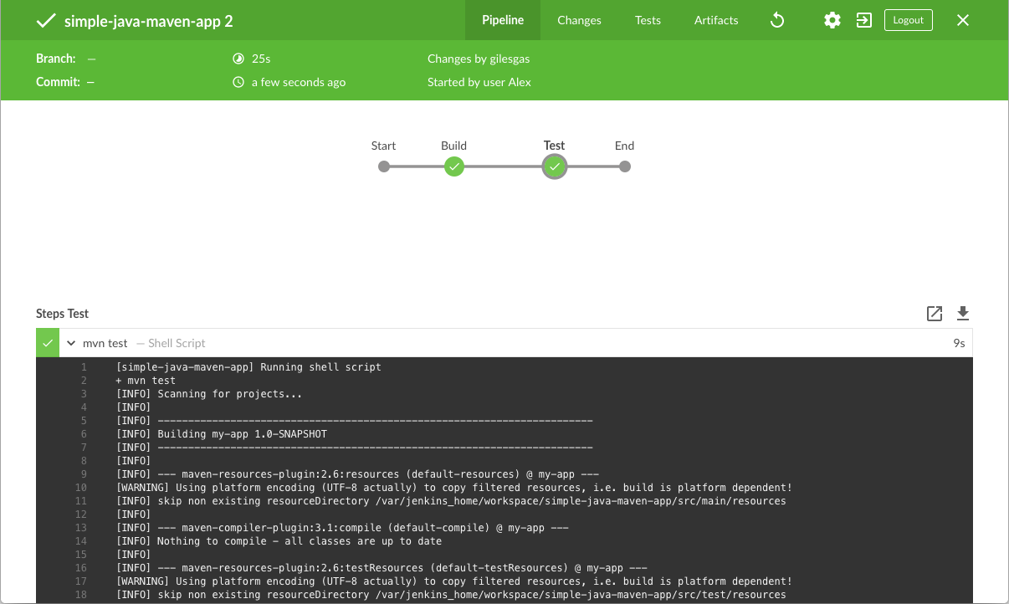

1. Click the **X** at the top-right to return to the main Blue Ocean interface.

### Add a final deliver stage to your Pipeline

1. Go back to your text editor/IDE and ensure your Jenkinsfile is open.
2. Copy and paste the following Declarative Pipeline syntax immediately under the Test stage of your Jenkinsfile:
3. stage('Deliver') {
4. steps {
5. sh './jenkins/scripts/deliver.sh'
6. }

}

and add a skipStagesAfterUnstable option so that you end up with:

pipeline {

agent {

docker {

image 'maven:3-alpine'

args '-v /root/.m2:/root/.m2'

}

}

options {

skipStagesAfterUnstable()

}

stages {

stage('Build') {

steps {

sh 'mvn -B -DskipTests clean package'

}

}

stage('Test') {

steps {

sh 'mvn test'

}

post {

always {

junit 'target/surefire-reports/*.xml'

}

}

}

stage('Deliver') {

steps {

sh './jenkins/scripts/deliver.sh'

}

}

}

}

|  |  |
| --- | --- |
|  | Defines a new stage called Deliver that appears on the Jenkins UI. |
|  | This [sh](https://www.jenkins.io/doc/pipeline/steps/workflow-durable-task-step/" \l "code-sh-code-shell-script) step (of the [steps](https://www.jenkins.io/doc/book/pipeline/syntax/#steps) section) runs the shell script deliver.sh located in the jenkins/scripts directory from the root of the simple-java-maven-app repository. Explanations about what this script does are covered in the deliver.sh file itself. As a general principle, it’s a good idea to keep your Pipeline code (i.e. the Jenkinsfile) as tidy as possible and place more complex build steps (particularly for stages consisting of 2 or more steps) into separate shell script files like the deliver.sh file. This ultimately makes maintaining your Pipeline code easier, especially if your Pipeline gains more complexity. |

1. Save your edited Jenkinsfile and commit it to your local simple-java-maven-app Git repository. E.g. Within the simple-java-maven-app directory, run the commands:  
   git stage .  
   then  
   git commit -m "Add 'Deliver' stage"
2. Go back to Jenkins again, log in again if necessary and ensure you’ve accessed Jenkins’s Blue Ocean interface.
3. Click **Run** at the top left, then quickly click the **OPEN** link which appears briefly at the lower-right to see Jenkins running your amended Pipeline project. If you weren’t able to click the **OPEN** link, click the top row on the Blue Ocean interface to access this feature.  
   If your amended Pipeline ran successfully, here’s what the Blue Ocean interface should look like. Notice the additional "Deliver" stage. Click on the previous "Test" and "Build" stage circles to access the outputs from those stages.

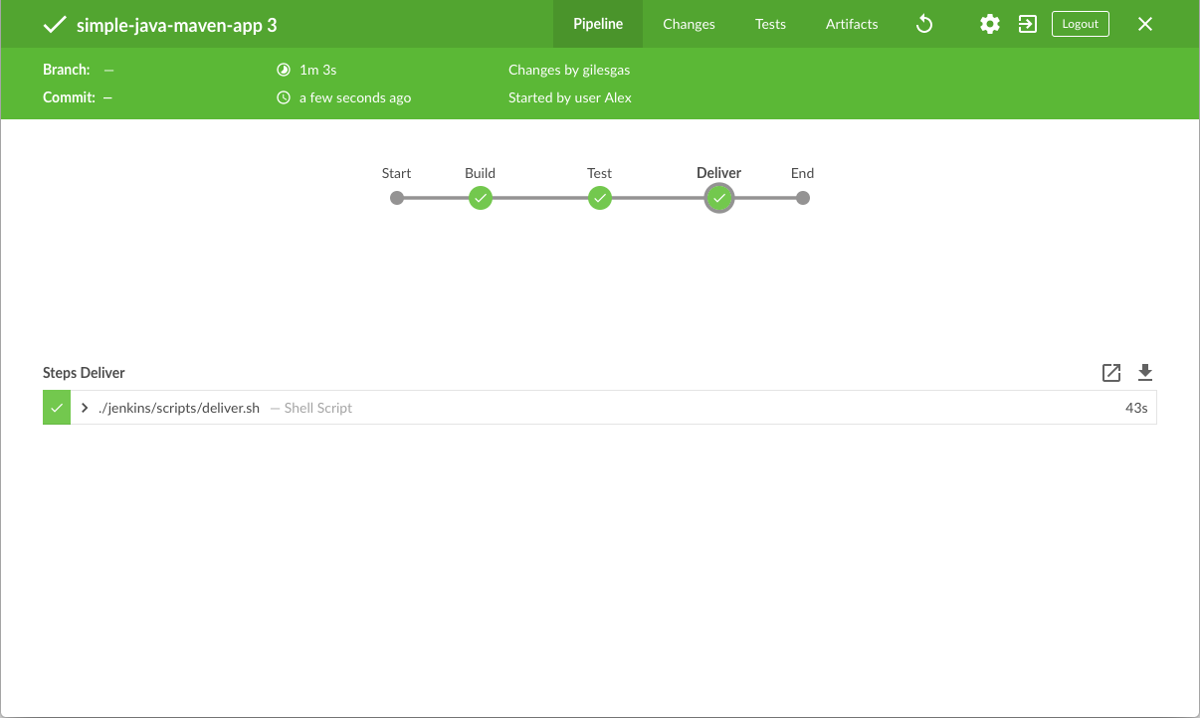

Here’s what the output of the "Deliver" stage should look like, showing you the execution results of your Java application at the end.

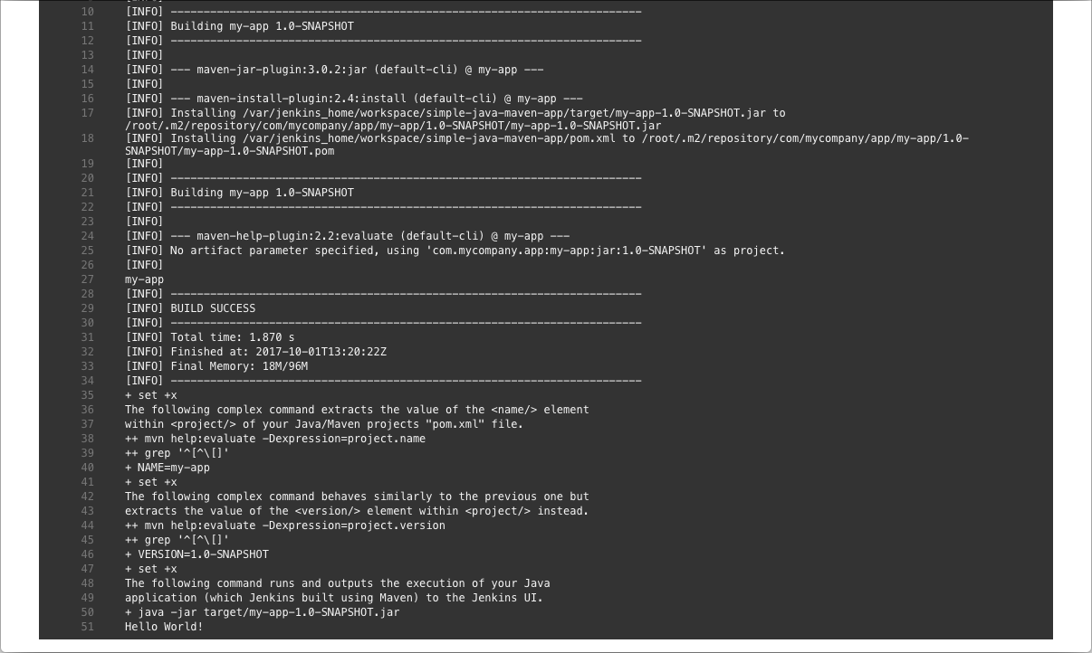

1. Click the **X** at the top-right to return to the main Blue Ocean interface, which lists your previous Pipeline runs in reverse chronological order.

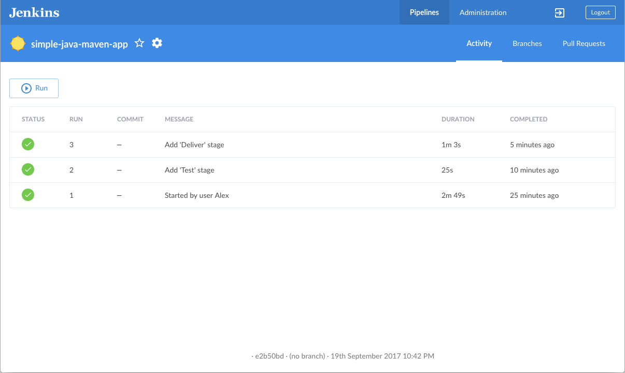

### Wrapping up

Well done! You’ve just used Jenkins to build a simple Java application with Maven!

The "Build", "Test" and "Deliver" stages you created above are the basis for building more complex Java applications with Maven in Jenkins, as well as Java and Maven applications that integrate with other technology stacks.

Because Jenkins is extremely extensible, it can be modified and configured to handle practically any aspect of build orchestration and automation.

**Conclusion**

The application is successfully built in Docker, and hosted in Docker Hub

 It is deployed on ELK stack on Docker and push application logs to it  
 an also I have madeAutomate Docker build and deployment using Jenkins pipeline code

**By making use of following tools:**

● Docker  
● Docker Compose  
● Elasticsearch  
● Logstash   
● Kibana  
● Spring Boot application